

**The Value of the Middle: How Middleware Powers Collaboration and Data Lineage in Modern Marketing**

Let’s face it: in today’s advertising and marketing technology landscape, data is everywhere-and it’s growing faster than ever. That was made even more evident when you look at the very detailed (and somewhat overwhelming) [MartechMap](https://martechmap.com/) that was published recently by [Chiefmartec](https://chiefmartec.com/) and [MartechTribe](https://www.martechtribe.com/) and the continued growth of data solution providers. Every campaign, every customer interaction, and every decision is fueled by data. But with this explosion of information comes a real challenge: how do you bring it all together, keep it secure and compliant, and make sure everyone in your organization is working from the same playbook? That’s where middleware steps in as the unsung hero of the modern martech stack.

*Source: Chiefmartec, MartechTribe*

**Middleware’s Moment: From Backroom to Boardroom**

Middleware used to be the behind-the-scenes tech that quietly connected your systems. Now, it’s front and center. The global middleware market is booming, expected to hit $129 billion by 2029, growing at over 7% annually. What’s driving this? The rise of AI, cloud adoption, IoT, and the sheer complexity of today’s business ecosystems. In fact, 72% of enterprises now rely on middleware to connect nearly five different marketing tools-up from just three a few years ago. Middleware isn’t just connecting systems; it’s enabling businesses to adapt, innovate, and thrive.

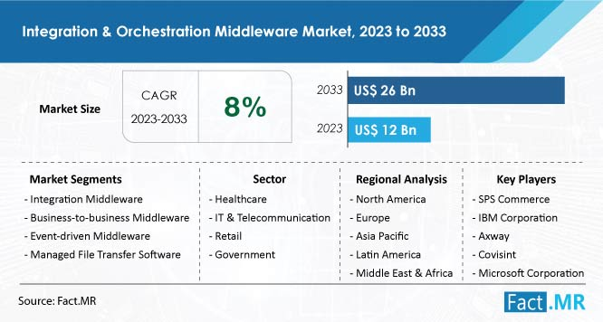

**Why Middleware Matters: The Real-World Benefits**

**Composable Architecture, Real Flexibility**  
Middleware lets you mix and match best-in-class tools-think CDPs, DSPs, CRMs-using API-first connectivity. This means you can upgrade your stack piece by piece instead of ripping and replacing everything at once. The result? A 360-degree customer view that pulls together insights from a dozen or more sources.

**Data Integrity and Lineage-No More Guesswork**  
With middleware, you get automated data lineage tracking, which speeds up attribution modeling by nearly 90%. Real-time validation checks cut down on data anomalies by 73%, and cross-platform identity resolution boasts matching rates over 92%. You can trust that your data is accurate, traceable, and ready for action. This is especially critical when it comes to compliance and auditability of the data and any changes to ensure proper attribution and verification…at a minimum, consider it a valuable insurance policy that provides proof of provenance and lineage.

**Security and Compliance, Built In**  
Centralized access controls reduce breach risks by more than two-thirds, while automated consent management keeps you compliant across 15+ channels. Middleware encrypts all data in transit, so sensitive information is always protected as it moves between systems.

**Operational Efficiency-Faster, Smarter, Leaner**  
Pre-built connectors mean campaigns launch 54% faster, and marketers can work with 83% less IT support. That’s a 360% return on investment from optimizing your stack and avoiding vendor lock-in while improving operational workflow.

| **Key Drivers** | **Key Restraints** |
| --- | --- |
| * The main driver for the integration and orchestration middleware market is the increasing demand for automation and system integration. * Businesses are adopting middleware solutions to enable efficient data management, real-time communication, and automated workflows, with about 58% of enterprises already using such solutions. * This trend is especially strong in industries like IT and telecommunications, where seamless communication is vital. | * Key restraints include security concerns and data privacy issues. * As more data is exchanged between systems, risks of breaches and data leakage grow, with over 47% of organizations identifying security as a major barrier to adoption. * Compliance with data protection laws also adds complexity, leading to slower adoption rates, particularly in highly regulated sectors like healthcare and finance. |

*Source:* [*https://www.globalgrowthinsights.com/*](https://www.globalgrowthinsights.com/)

**Middleware in Action: Use Cases That Move the Needle**

* **Cross-Channel Attribution Modeling:** Middleware brings together data from paid media, owned channels, and CRMs, enabling accurate multi-touch attribution across an average of 7.2 customer touchpoints. This holistic view helps you see what’s really driving results.
* **Real-Time Personalization Engines:** By integrating customer profiles, AI models, and content systems, middleware powers dynamic creative optimization-boosting conversion rates by up to 32%.
* **Privacy-Compliant Audience Activation:** Middleware orchestrates consent, data clean rooms, and identity resolution, enabling 78% match rates for cookieless targeting as third-party cookies fade away.
* **Collaborative Workflow Automation:** By connecting project management, creative, and approval workflows, middleware can shrink campaign launch cycles from two weeks to just 48 hours.

**What’s Next? Middleware’s Evolving Role**

The middleware space is moving fast. AI-powered anomaly detection now flags 94% of data discrepancies before campaigns go live, while auto-scaling infrastructure handles sudden traffic spikes with ease. [Blockchain](https://www.linkedin.com/pulse/why-blockchain-based-proofing-critical-data-integrity-ai-compliance-nqdzc/?trackingId=g%2Byg6WtS4g0cT1uq4V5IaA%3D%3D) is starting to provide immutable audit trails, making compliance and data lineage even more robust.

As marketing and advertising ecosystems get more complex and fragmented, middleware’s value only grows. Companies using these solutions see time-to-market that’s four times faster and marketing ROI nearly three times higher than those using old-school, point-to-point integrations. With more than three-quarters of CMOs prioritizing composable tech stacks, middleware isn’t just nice to have-it’s essential for balancing innovation with operational stability.

**The Takeaway**

Middleware is the backbone of modern data orchestration in advertising and martech. It breaks down silos, fosters collaboration, and ensures data lineage, empowering organizations to deliver personalized, compliant, and effective customer experiences at scale. In a world where data is only getting more complex, the “middle” is where the real value-and your competitive edge-lives.

About Precise.ai

Precise is a leader in data verification and secure collaboration, specializing in Proof of Data technology to ensure transparency, trust, and compliance. Through blockchain-backed proof methodologies, Precise provides data owners with an immutable record of accuracy, lineage, and responsible data use. In addition to data verification, Precise enables privacy-preserving data collaboration through federated machine learning, allowing organizations to extract insights and drive value while keeping sensitive data protected and decentralized. By establishing verifiable data integrity and privacy-first data activation, Precise empowers businesses to confidently leverage their data while maintaining compliance and accountability. Contact us at [info@precise.ai](mailto:info@precise.ai).